BIS.TIF

On-line Reporting Portal

**USER GUIDE**

Department of National General Secretary

Ahmadiyya Muslim Jama‘at Canada

**Revision History**

V.1.0 – Initial version

V.1.1 – Oct. 10, 2010

V.1.2 – Sept. 2, 2013

V.1.3 – Nov. 6, 2014

V.1.4 – Aug. 10, 2015

V.2.0 – Oct. 2, 2015

This document is the property of the Office of National General Secretary. No part of this document is to be reproduced without prior written permission from the Office of General Secretary.

National General Secretary can be contacted at:

905 832 2669 ext. 2243

gs@ahmadiyya.ca

www.ahmadiyya.ca | www.alislam.org

fax: 905 832 3220

**Purpose**

The Online Reporting System is built to facilitate the timely submission of departmental reports and other administrative functions. This **User Guide** provides the reader with the information needed to use this system.

**What is needed?**

Each office bearer needs to have a **User ID,** and a **Password**. This information is provided by the General Secretary of the Jama‘at or the National General Secretary and should be kept confidential.

**Report Submission Process**

The report submission process consists of the following easy steps:

Step 1: Login

Step 2: Prepare/Edit Report

Step 3: Submit

Before beginning, one should familiarize with the reporting system user interface.

1. **User Login**

Go to https://reports.ahmadiyya.ca. The main login screen will appear.

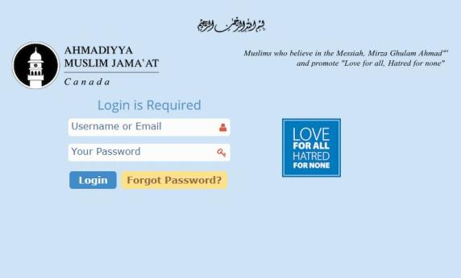

Insert the login information in the respective fields to access the reporting system. You can login with your **email address** or with your **username**.

1. **Reporting System Home Page**

After a successful login, the main dashboard will appear. What information is displayed depends on which office bearer is logging in.

Shortcutss

Shortcuts

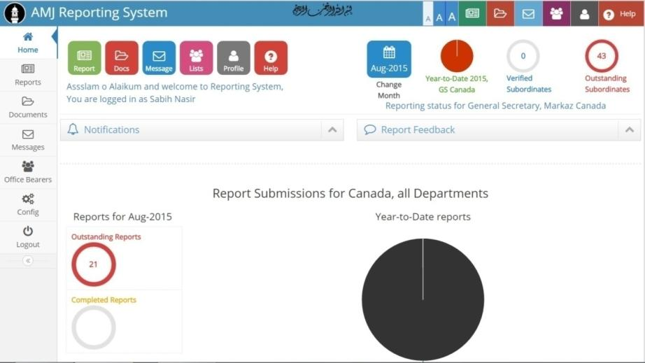

Feedback Regarding your Reports

Information about your Department

Report Submissions Stats for the Current Month

General Notifications

Report Submissions Information for the Year

Menu Buttons

This page is divided into a few different sections.

1. **Menu Shortcuts:**
   1. There are 3 different sets of menu shortcuts that allow access the major tools of the site.
2. **General Notifications**
   1. Any alerts or actions from the system. This includes emails from Markaz as well.
3. **Feedback Regarding your Reports**
   1. Contains reporting feedback received by the Jama‘at/Markaz.
4. **Report Submissions Stats for the Current Month**
5. **Report Submissions Information for the Year**
   1. Shows at a glance the YTD information about your department.
6. **Information Regarding the Department of the person logged in**

**Menu Buttons**

**The various tabs available in the Menu on the left:**

|  |  |
| --- | --- |
| Menu Tabs - Left _new.jpg | **Home:** Click here to go back to the main dashboard from anywhere in the site. |
| Menu Tabs - Left _new.jpg | **Reports:** Click here to create new reports, show lists of all previous reports categorized by Branch and Department, as well as create comprehensive analysis of each Branch and Department. |
| Menu Tabs - Left _new.jpg | **Documents:** Click here to view a list of various Jama‘at documents covering a range of topics. Users can upload their own documents and set security policies allowing only designated members to access those documents. This is the most secure way to transfer documents. |
| Menu Tabs - Left _new.jpg | **Messages:** Click here to access the inbox to read messages you have received from other users, the reporting system alerts, as well as compose emails to send to other users. |
| Menu Tabs - Left _new.jpg | **Office Bearers:** Click here to view a list of all the current office bearers of each Branch related to a Department in the country. |
| Menu Tabs - Left _new.jpg | **Logout:** Click here to log out of the reporting portal. |

**Menu Shortcuts**

**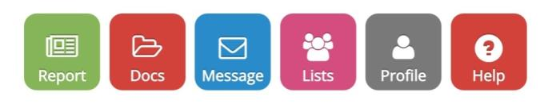  
These tabs include some of the same shortcuts as the Menu Buttons, such as the Report, Documents, and Message tabs, which all link to their respective pages. There are also three new shortcuts included here:**

**Lists:** The user has the ability to search and sort through the list of Office Bearers (related to the department) by Name, Username, Phone Number, Email, Branch, and Department.

**Profile:** This shortcut links the users to their profile. They can view and change their basic personal information. The users can also change their password as well as change personal settings for the reporting site such as text size, color, etc.

**Help:** A comprehensive help section is available with Q/A sections, a complete User Guide & helpful videos.



These shortcuts are identical to the above Dashboard Shortcuts with the addition of a Text Size tab, which allows the user to instantly change the size of all text and buttons throughout the site by choosing one of the three available options. These Shortcuts are also available site wide, and can be accessed from the top menu.

Middle Section: **MAIN REPORTING OPTIONS**

**Departmental Reports**

The following section explains the process of submitting a new report, editing a previously saved draft report, and viewing previously submitted reports.

**Submitting a New Report**

Clicking on the **Reports** button will open the drop down menu that provides the option for:

* Creating new reports
* List view of reports to:
  + Edit previously created reports or
  + View previously submitted reports.
* Analysis

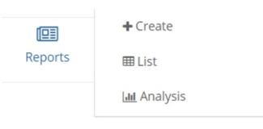

To create a new report press the **Create** button in the drop down menu or click on the link as shown below:

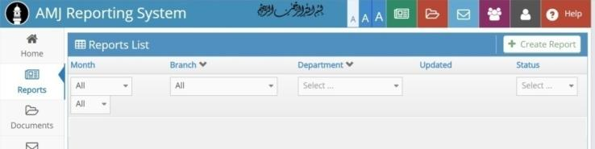

Click to create new report

When the Create Report section is clicked, some questions are asked. For example, to submit a report for the General Secretary Department for the month of August 2015,select **General Secretary** in the drop down menu for **Department.** Similarly select **Aug-2015** for month and the name of your branch.

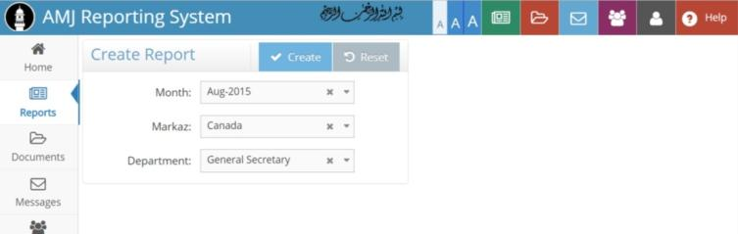

Click on **Create** button to create the monthly report

**Note:** Various departments have their specific questions that their respective secretaries have to fill out.

In the text box below this instruction, you can list down all the activities for the month. You can also attach a file related to your report that has details of the activities.

**Note**: Please attach documents **ONLY** when necessary. It is preferable that report is submitted in text form in the given fields.

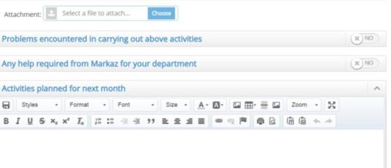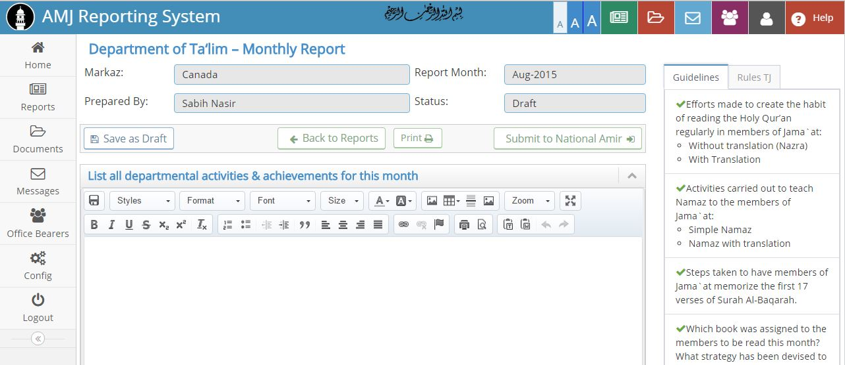

Questions/

Instructions

The **TJ** tab provides the rules as specified in the Tahrik Jadid Rule Book

**Guidelines** provides with hints for preparing the report

These questions are marked **NO** by default. Only fill if required.

To attach a file, click on **Choose** to upload the file

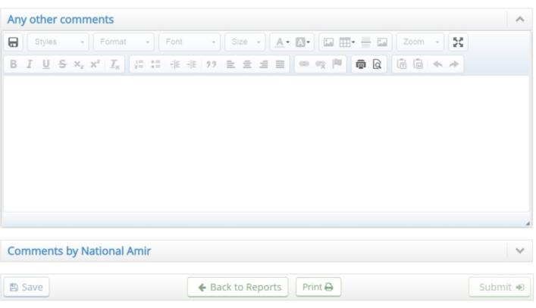

Click on the **Submit** button when the report is complete

General comments section

**NOTE:** **A report can be saved as draft at any time. Once it is complete, the Secretary submits the report to the local Amir /Sadr for review and verification.**

**SUMMARY**

The report submission process can be summarized as follows:

1. Login at https://[reports.ahmadiyya.ca](https://www.ahmadiyya.ca/reports) with the given **User ID** & **Password**.
2. From Reports, go to **+Create**.
3. Select the month to create the report for. In case the person logged in has more than one department, select the department as well.
4. Answer all relevant questions and report the activities for the month.
5. Save as draft to come back to it at a later time; or press **Submit** to send the report for the local Amir/Sadr.
6. Local Amir/Sadr reviews and submits the report.

**Viewing Reports**

To view a previously submitted report, go to **Reports** and click on **List** in the drop down menu.

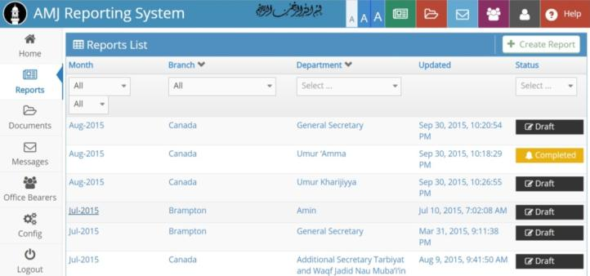

Select the various parameters on top of the page. For example, to view the report of **General Secretary** Department for **August 2015** which was saved as **Draft,** select **August** under **Month, 2015** in **Year, General Secretary** in **Department** and select **Draft** in **Status**. As the selections are being made the list dynamically becomes shorter.

To **Edit** or **View** a report saved as **Draft,** click on the link of the report.

**Analysis**

The following section explains the **Analysis** option in the left menu:

**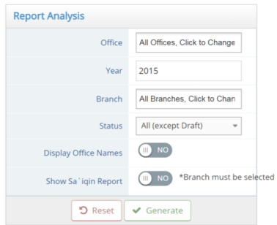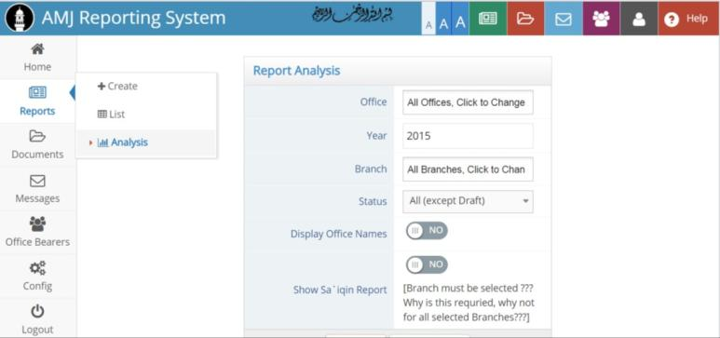**

1. **Office** – select a specific department
2. **Year** – type in a specific year
3. **Branch** – select the branch
4. **Status** – select the status of the reports to be analyzed
5. **Display Office Names** – shows for each month which department submitted the report and its status
6. **Show Sa’iqin Report** – shows the status of ‘Amila meetings, Ijlas ‘Am meeting and Sa’iqin activity report

**Password**

The following section explains the **Password Change** option in the **User Profile** menu:

**Change Your Password**

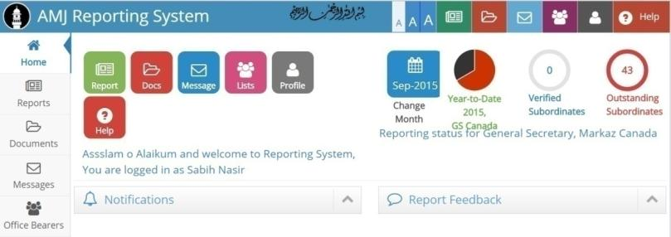

**1.** In the **Home** window click on the **Profile** icon.

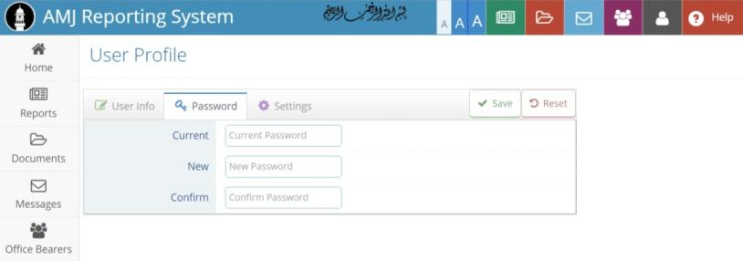

1. In the **User Profile** section click on the **Password** tab.
2. Type in the current password in the **Current Password** field.
3. In the **New Password** field, enter the new password.
4. In the **Confirm Password** field, re-enter the new password.
5. Click on the **Save** button.

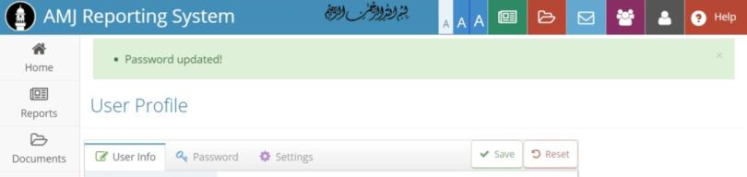

Once the new password is saved, a confirmation message will be displayed.

**Password RECOVERY**

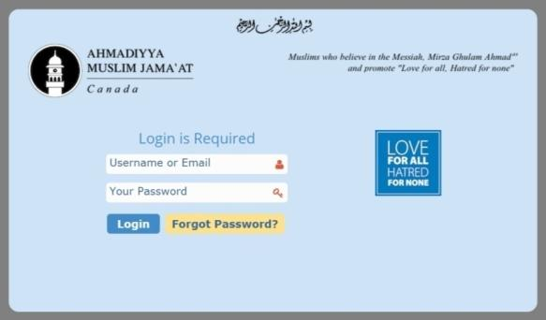

1. On the **Login Screen** click on the **Forgot Password** link to be redirected to the next page.

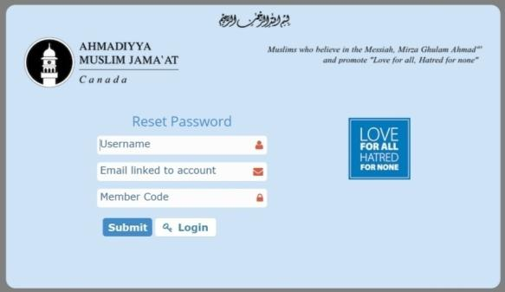

1. Type in the **Username**, **Email** address linked to the account and your **Member Code** in the respective fields.
2. Click on the **Submit** button.
3. If any of the three pieces of information asked do not match, an error will be displayed.

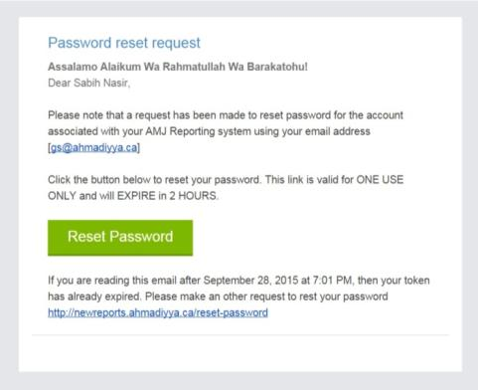

1. Click on the **Reset Password** button to initiate the reset.

**BRANCH USERS**

*This section is for Local Amir/President and General Secretary only. The following section explains the use of Branch User option in the menu.*

**Viewing Branch Users**

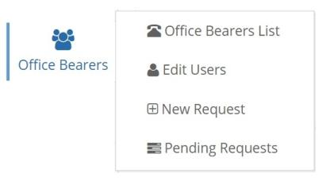

Clicking on the **Office Bearers** button will bring up the drop down menu with the following options:

1. **Office Bearers List**
   * Contains contact information of office bearers.
2. **Edit Users**
   * Modify and change information about office bearers.
3. **New Requests**
   * Submit a request to change or add office bearers.
4. **Pending Requests**
   * Status of Office Assignment Requests.

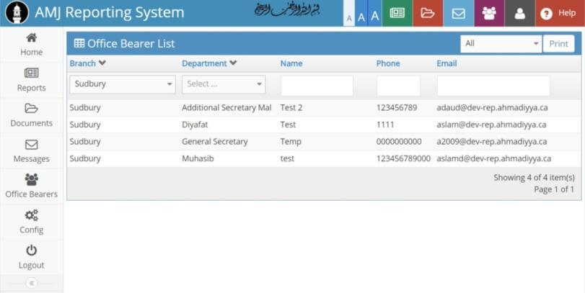

The list can be customized be selecting the various filler fields on the top.

**NOTE: Only the local Amir/Sadr or General Secretary of a Jama‘at has the ability to add or edit an Office Bearer.**

**Edit Office Bearers Info**

Click on **Edit Users** in the drop down list

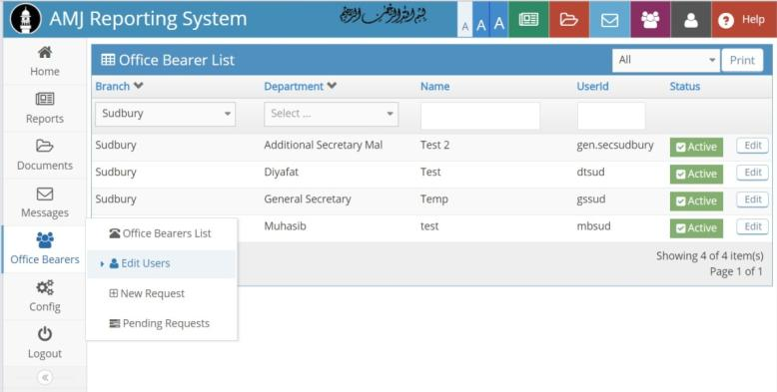

Click on the **Edit** button to modify the information of the Office Bearer on the popup screen

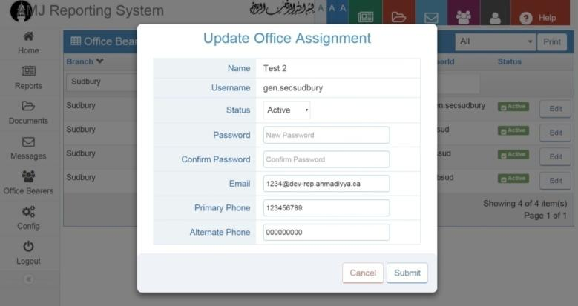

Once the changes are made, click on the **Submit** button to save the changes.

Once approved by the National General Secretary’s office, the status will be marked as **Active**.

**Add New Branch User**

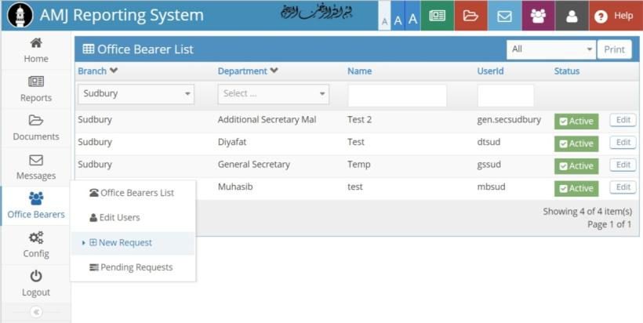

Click on the **New Request** button in the drop down list to enter the information of the new Office Bearer.

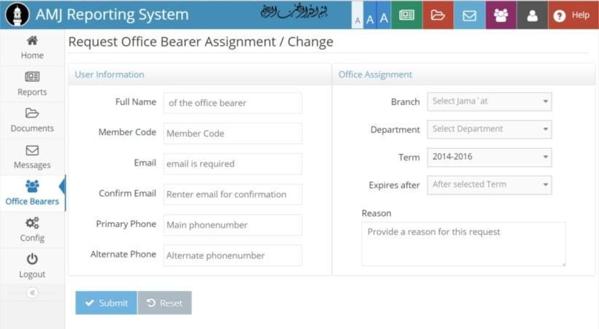

**A reason for the request to initiate the change needs to be provided**

Once you all the required information is entered, click on the **Submit** button. The status of the edited user will become **Active** once verified and approved by National Markaz.

**Conclusion**

Once understood properly, the report submission tool will make it easier to submit and manage reports online. Enhancements to this tool will be brought as required and the users will be updated about the enhancements.

For any further information, please contact the **National General Secretary’s Office** at:  
905-303-4000 ext. 2243